While we were unaware that we needed to provide more than updates of our progress, we are happy to explain some of the technical works and issues we have encountered throughout this project.

Initially, our first step was to create a sort of "payload" that can move smoothly move across a linear track. This payload must also carry a spinning "time disk" which will be used for determining instantaneous rate of change points in our integral later. To build this, we first measured out a piece of wood that would fit as a concentric square inside of our time disk and cut it out. Then, we attempted to mount our linear slides to the payload before realizing that we needed to switch to housing bearings instead due to poor quality of materials. After lining up the system with the poles through the housing bearings, the makeshift linear slides were Gorilla glued onto the payload. Next, a hole was cut through the payload to account for the DC motor. After racking our brains for a secure way to support the disk, we decided to use a lazy Susan bearing which would allow the disk to revolve in a perfect circle. Next, we learned that our DC motor would also fail due to poor quality of materials and a torque below the minimum required for our specification. After ordering a new motor, we mounted this to the bottom of our payload using a perfectly drilled hole, two screws, and more Gorilla glue. We ensured that the motor favored one side of the payload so that the pulley belt could be strung under the other side of the payload.

Next, we secured a wood frame that would support our entire system. We built this frame from pieces of 1"x4" wood and waited until we were absolutely sure of our design before screwing the pieces together. With a wood frame intact, we were ready to begin lining up the pulley belt. We measured out and created a hanging piece of wood underneath the payload, which had mounting brackets which align with our pulley belt teeth secured onto it. In this way, we lined up where our pulley belt would go by gluing the pulley belt to each end of the mounting bracket. With this done, all that needed to happen was constructing a manner for the pulley belt to be attached to each end of the system. We created one static end of the system by mounting a perpendicular piece of wood (secured by angle brackets) and letting the end of a bisecting screw rotate freely with the belt wrapped around it. The other end would be our stepper motor, which needed a system for allowing it to be mounted and unmounted from our system so that we may continue to work on different parts. To do this, we again made a perpendicular piece of wood (secured by angle brackets) that, at the adjustment of a single screw, allows the stepper motor to be removed or attached to the system. This marked the completion of the pulley system, which we followed with attaching the time disk to our payload. Tests to our DC motor and stepper motor found that each component worked separately (to move the payload or spin the disk respectively) and that GPIO support was all we needed to complete this code. We could not test everything together because we lacked our perf board at this time.

Finally, the construction of the mechanical portion of this project would be completed by attaching the encoder. To do so, we realized a slight modification to our design that expedited the process greatly. As opposed to creating a housing for a top beam which would contain a wheel and spin a rod which would then be read by the encoder, we realized that, due to the static nature of our "follower disk", all that was required was a wood beam support spanning the width of our project that included the encoder directly mounted to our follower disk. We measured the center of the track and built 1.5" outwards from each side before using our 1"x3" beams to construct a frame for which the encoder would be mounted across. The follower disk could be mounted directly to the encoder by simply using an Allen key to tighten the mounting bracket of the follower onto the encoder. Attaching the encoder to the wood beam would require slightly more ingenuity. To achieve this, three 3" screws were set around the spacing of the encoder in the form of an equilateral triangle. By securing the encoder against the wood beam in this manner, the encoder remained static, and we no longer had to deal with the issue of the encoder resting only 1/2" above the time disk. The final issue we ran into with the encoder was that, by statically mounting it, it relied on the time disk being perfectly level, which we realized was not the case. To account for this issue, we needed to allow the encoder/wheel combo to be able to move vertically by small amounts to stay in constant contact with the time disk. We sawed through our recently mounted wood beam, and, using some thin sheet metal pieces that we cut, secured the encoder/wheel piece so that it may only move in small variations vertically.

This is where we are now. We have a good portion of the code prepared for testing, though not entirely finished for production. Our PCB boards have just arrived, and we can now finally test the entire mechanism together in unit tests.

Some pictures of the machine will be attached below so that it may be easier to picture the above description. This is the final mechanical nature of our machine, which is now only missing a few soldered electronics in the physical domain.

Additionally, we have many, many time lapses if those would help show some of the technical work we have done on this project. I can set these up in a Google Drive later if deemed helpful.

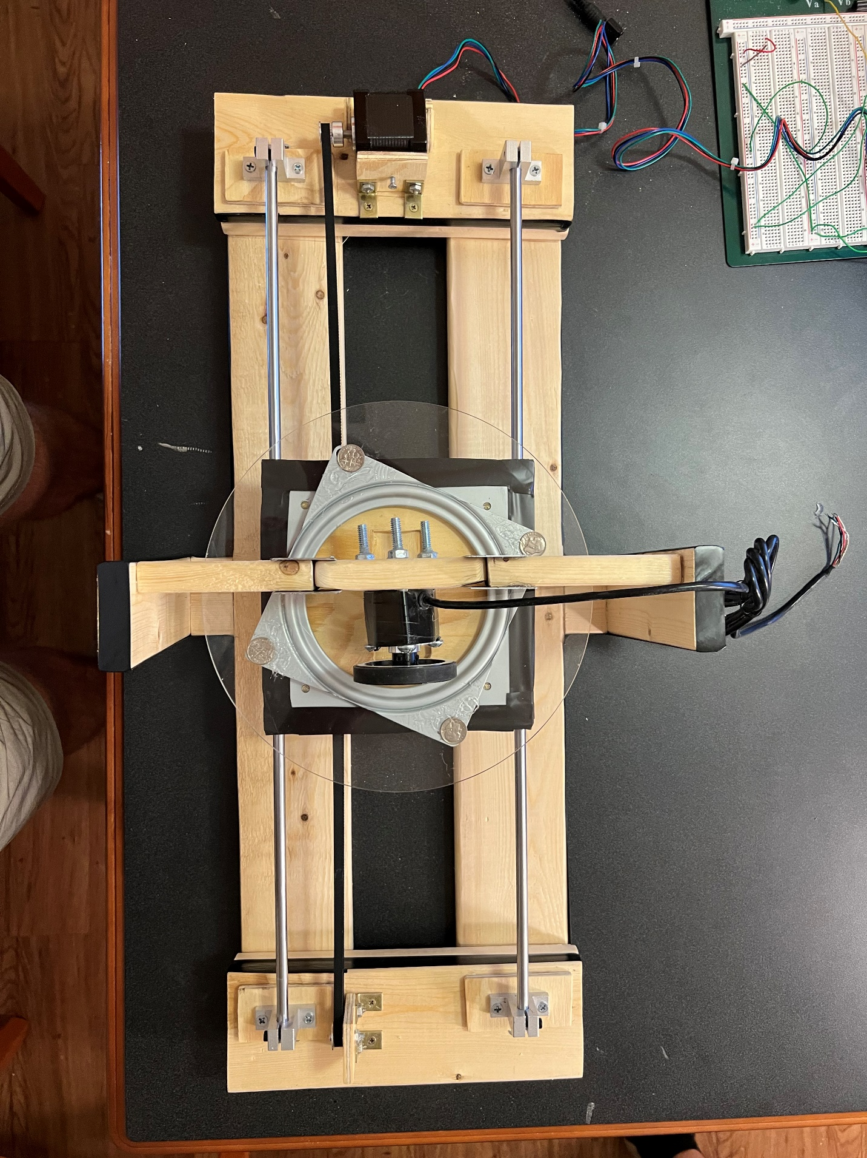

Static end of pulley

Time Disk

Follower Disk

Stepper Motor

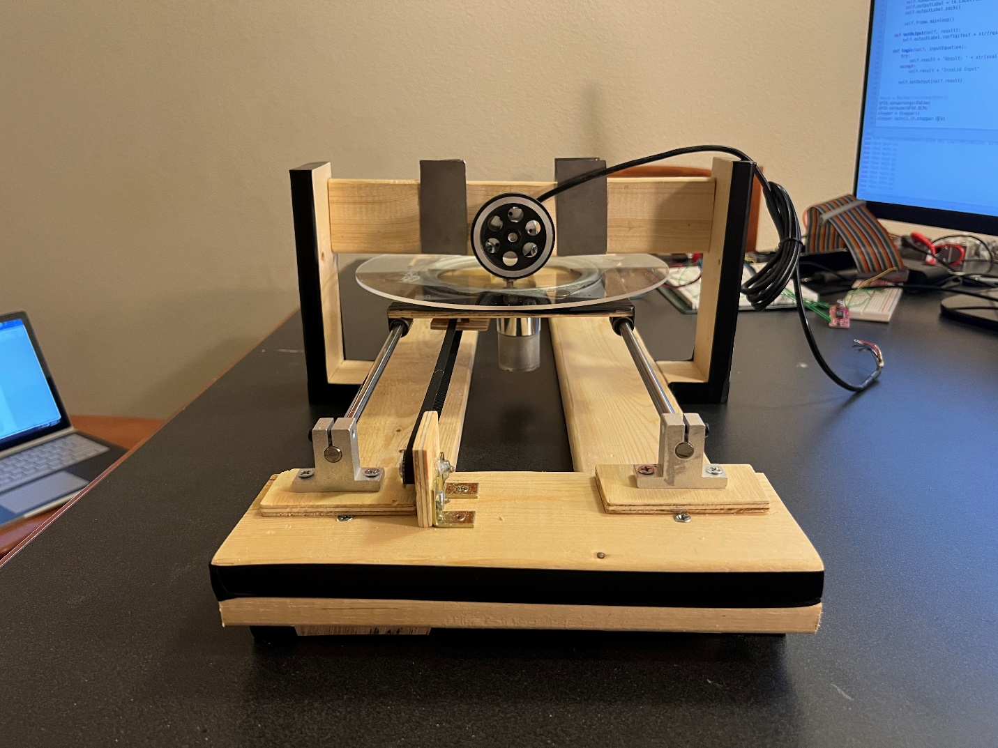

DC Motor

Follower Disk

Time Disk

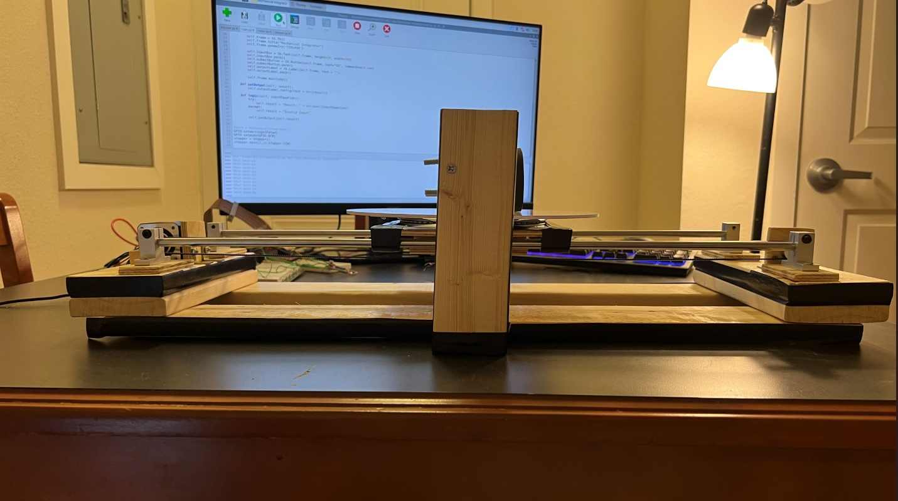

Follower Disk

Static end of pulley

Stepper Motor